**Question #1**

Write an SQL query to display

The number of full time and part time instructors

Your output should contain 2 columns in the below-mentioned order

|  |  |
| --- | --- |
| **type** | **count** |

Use Alias count for the second column.

You can view the database schema by clicking the View Schema tab at the bottom of the query window on the right-hand side of the screen.

**Instructor Table**

* last_name
* type (full-time, part-time etc.)
* section_id (nullable)
* instructor_id

SELECT type, COUNT(*) AS count

FROM instructors

WHERE type IN ('Full Time', 'Part Time')

GROUP BY type;

**Question #2**

Write an SQL query to find:

The employee ID and employee name of all the employees who have not been assigned a department yet.

Your output should contain 2 columns in the below-mentioned order.

|  |  |
| --- | --- |
| **EMPID** | **EMPNAME** |

You can view the database schema by clicking the View Schema tab at the

bottom of the query window on the right-hand side of the screen.

1. **Employee Table**
   * EMPID (employee id)
   * EMPNAME (employee name)
   * DEPTID (nullable, department id)
   * DOB (date of birth)
   * JOINING_DT (joining date)

SELECT emp_id AS EMPID, emp_name AS EMPNAME

FROM employees

WHERE dept_id IS NULL;

**Question #3**

Write an SQL query to display:

The number of students who have opted for BSc Mathematics (use alias no_of_students).

Note: A student must be registered if he has opted for a course and a course is taught under a section. Also, the course name and course type are stored in the "Course" table.

Your output should contain 1 column in the below-mentioned order.

|  |
| --- |
| **no_of_students** |

You can view the database schema by clicking the View Schema tab at the bottom of the query window on the right-hand side of the screen.

SELECT COUNT(*) AS no_of_students

FROM Registration r

JOIN Section s ON r.section_id = s.section_id

JOIN Course c ON s.course_id = c.course_id

WHERE c.course_name = 'BSc Mathematics';

**Question #4**

Write an SQL query to display:

The details of the customers whose name starts either with letter C or P.

Your output should contain 6 columns in the below-mentioned order.

|  |  |  |  |  |  |
| --- | --- | --- | --- | --- | --- |
| **customer_address_id** | **customer id** | **first_name** | **address** | **phone** | **email** |

You can view the database schema by clicking the View Schema tab at the bottom of the

query window on the right-hand side of the screen.

SELECT

ca.customer_address_id,

c.customer_id,

c.first_name,

a.address,

a.phone,

c.email

FROM customer c

JOIN customer_address ca ON c.customer_id = ca.customer_id

JOIN address a ON ca.address_id = a.address_id

WHERE c.first_name LIKE 'C%'

OR c.first_name LIKE 'P%';

**Question #5**

Write an SQL query to display:

The details of the costliest product.

Your output should contain 4 columns in the below-mentioned order.

|  |  |  |  |
| --- | --- | --- | --- |
| **product id** | **code** | **name** | **unit price** |

You can view the database schema by clicking the View Schema tab at the bottom of the

query window on the right-hand side of the screen.

**Question #6**

Write an SQL query to display:

The last name of the instructor who has no section assigned.

Your output should contain 1 column in the below-mentioned order.

|  |
| --- |
| **last_name** |

You can view the database schema by clicking the View Schema tab at the bottom of

the query window on the right-hand side of the screen.

**Question #7**

How to attempt questions:

Question:

Write an SQL query to display:

The username of the customers who have placed an order.

Your output should contain 1 column in the below-mentioned order.

|  |
| --- |
| **username** |

You can view the database schema by clicking the View Schema tab at the bottom of the query window on the right-hand side of the screen.

**Question #8**

Write an SQL query to find:

The type description and the count (use alias count) of each type of train from the train details table.

Your output should contain 2 columns in the below-mentioned order.

|  |  |
| --- | --- |
| **type_description** | **count** |

You can view the database schema by clicking the View Schema tab at the bottom of the query window on the right-hand side of the screen.

**Question #9**

The last name of the students who registered in the month of June. Arrange the output data in the ascending order of their last name.

Your output should contain 1 column in the below-mentioned order.

|  |
| --- |
| **last_name** |

You can view the database schema by clicking the View Schema tab at the bottom of the query window on the right-hand side of the screen.

**Question #10**

The employee ID, employee name and joining date of all employees who join before 1st January 2005.

Your output should contain 3 columns in the below-mentioned order.

|  |  |  |
| --- | --- | --- |
| **EMPID** | **EMPNAME** | **JOINING DT** |

Hint: The dates in employee_info table are stored as 'YYYY-MM-DD'

Note: Do not use an alias.

You can view the database schema by clicking the View Schema tab at the bottom of the query window on the right-hand side of the screen.

**Question #11**

Write an SQL query to display:

The employee ID, employee name, date of birth (DOB) and age (in years without decimals) of all employees (use alias name Age).

The result must be sorted in ascending order as per the employee ID

Note: Floor your age variable.

Your output should contain 4 columns in the below-mentioned order.

|  |  |  |  |
| --- | --- | --- | --- |
| **EMPID** | **EMPNAME** | **DOB** | **AGE** |

You can view the database schema by clicking the View Schema tab at the bottom of the query window on the right-hand side of the screen.

**Question #12**

Write an SQL query to display:

The number of courses having a 3-year term (use alias No_of_courses).

Your output should contain 1 column in the below-mentioned order.

|  |
| --- |
| **No_of_courses** |

You can view the database schema by clicking the View Schema tab at the bottom of the query window on the right-hand side of the screen.

**Question #13**

The last name of the students who registered at the last. Your output should contain 1 column in the below-mentioned order.

|  |
| --- |
| **last_name** |

You can view the database schema by clicking the View Schema tab at the bottom of the query window on the right-hand side of the screen.

**Question #14**

Write an SQL query to display:

The department name for which no instructors are available.

Your output should contain 1 column in the below-mentioned order.

|  |
| --- |
| **name** |

You can view the database schema by clicking the View Schema tab at the bottom of

the query window on the right-hand side of the screen.

1.Refer to the Employee' table given below. How is the multivalued dependency represented in thes table?

Choose the best option

1.Employee_ID -> Salary, Location

2.Employee_ID -> Salary Employee_ID -> Location

3.Employee_ID -> Salary

4.Employee_ID -> Location

2.A company needs to ensure transactional ACID property usage with the help of data items storage structure. The storage used must be of a kind that is susceptible to failure which may result into loss of information Which storage structure should be used by the company here?

1.Volatile

2.Non-volatile

3.Stable

4.Unstable

3. A database is designed in such a way that if its address is not provided, then a new user can never be inserted into the table. What is the problem with this design?

1.Database is not normalised

2.Address can be a multivalued attribute

3.There is a functional dependency between two entities i.e. user and address. Hence nee normalise the design.

4.Decomposition of relation

4. Look at the given image of two tables A and B

Are the outputs of the relational algebra operations A-B and B-A the same?

1.The outputs of A-B and B-A are the same

2.The outputs of A-B and B-A are different.

3.The outputs of A-B and B-A are different on different hardware.

4.No relational algebraic operation is possible on tables A and B.

5.Write an SQL query to display:

The last name of the instructor who has no section assigned.

Your output should contain 1 column in the below-mentioned order.

last name

You can view the database schema by clicking the View Schema tab at the bottom of the query window on the right-hand side of the screen.

6. Write an SQL query to display:

The details of the customers whose first name and last name does not contain the letter Display the result in the alphabetical order of their first name

Your output should contain 6 columns in the below-mentioned order

Customer_address_id

Customer_id

First_name

address

phone

email

You can view the database schema by clicking the View Schema tab at the bottom of the query window on the right-hand side of the screen

Write an SQL query to display:

The last name of the students who have received grade C either in their midterm or full-term.

Your output should contain 1 column in the below-mentioned order.

last name

You can view the database schema by clicking the View Schema tab at the bottom of the query window on the right-hand side of the screen.

Write an SQL query to display:

The publisher name and the total number of books published by each of them Use the alias Total Books for the total number of books

Your output should contain 2 columns in the below-mentioned order

PublisherName Total_Books

You can view the database schema by clicking the View Schema tab at the bottom of the query window on the right-hand side of the screen

Write an SQL query to display:

Reve

The last name of the students who have received grade C either in their medtlermo full-term.

Your output should contain 1 column in the below-mentioned order

last name

You can view the database schema by clicking the View Schema tab at the bottom of the query window on the right-hand side of the screen

The employee ID, employee name and the total number of leaves taken individually by each employee, if they have taken any leave (use Total_Leaves as alias).

Hint: For example, if an employee with employee code 'E001' has taken leaves for 2 days in January and for 3 days in February, then the total number of leaves will be 5 days. Similarly, display the total number of leaves taken individually by each employee in case they have taken any leave. The information on leaves is stored in the "EMP_LEAVE_INFO" table.

Your output should contain 3 columns in the below-mentioned order.

EMPID

EMPNAME

TOTAL_LEAVES

You can view the database schema by clicking the View Schema tab at the bottom of the query window on the right-hand side of the screen.

Vrite an SQL query to display:

The last name of the instructor who has no section assigned

Your output should contain 1 column in the below-mentioned order.

last name

You can view the database schema by clicking the View Schema tab at the window on the right-hand side of the screen

Write an SQL query to display:

The last name of the students who have received grade C either in their midterm or full-term.

Your output should contain 1 column in the below-mentioned order.

last name

You can view the database schema by clicking the View Schema tab at the bottom of the query window on the right-hand side of the screen.

select last name from student

where student_id in

(select student_id from registration where midterm_grade=fullterm_grade);

How to attempt questions:

Question:

Write an SQL query to display

The usemame of the customers who have placed an order.

Your output should contain 1 column in the below-mentioned order:

username

You can view the database schema by clicking the View Schema tab al the bottom of the query window on the right-hand side of the screen

Write an SQL query to display:

The last name of the students who scored consistently during their midterm and f

Your output should contain 1 column in the below-mentioned order.

last name

H

You can view the database schema by clicking the View Schema tab at the botto

query window on the right-hand side of the screen.

How to attempt questions:

Question:

Write an SQL query to display:

The rooms occupied by the section on Monday from 9-11 am

Note: The day and time are mentioned in the "schedule" table

Your output should contain 1 column in the below-mentioned order.

room

You can view the database schema by clicking the View Schema tab at the bottom of the query window on the right-hand side of the screen.

Question:1

Write an SQL query to display:

The last name of the instructor who has no section assigned.

Your output should contain 1 column in the below-mentioned order.

last_name

You can view the database schema by clicking the View Schema tab at the bottom of the query window on the right-hand side of the screen.

Question: 2

Write an SQL query to display:

The username of the customers who haven't placed an order yet

Your output should contain 1 column in the below-mentioned order

username

You can view the database schema by clicking the View Scheme query window on the right-hand side of the screen

Question:3

White an SQL query to display.

The room occupied by the section on Monday from 9-11 am.

Note: The day and time are mentioned in the "schedule" lab

Your output should contain 1 column in the below-mentioned order.

Room

Q4

Write an SQL query to display:

The employee ID, employee name and the total number of leaves taken individually by each employee, if they have taken any leave (use Total Leaves as alias).

Hint: For example, if an employee with employee code "E001' has taken leaves for 2 days in January and for 3 days in February, then the total number of leaves will be 5 days. Similarly, display the total number of leaves taken individually by each employee in case they have taken any leave. The information on leaves is stored in the "EMP_LEAVE_INFO" table.

Your output should contain 3 columns in the below-mentioned order.

EMPID EMPNAME TOTAL_LEAVES

You can view the database schema by clicking the View Schema tab at the bottom of th

query window on the right-hand side of the screen.

Question :5

Write an SQL query to display:

The employee ID, employee name, date of birth (DOB) and age (in years without decimals) of all employees (use alias name Age).

The result must be sorted in ascending order as per the employee ID.

Note: Floor your age variable.

Your output should contain 4 columns in the below-mentioned order.

EMPID

EMPNAME

DOB

AGE

You can view the database schema by clicking the View Schema tab at the bottom of the query window on the right-hand side of the screen

Question:6

Write an SQL query to display.

The last name of the students who registered in the month of June. Arrange the output data in the ascending order of their last name.

Your output should contain 1 column in the below-mentioned order.

Last_name

You can view the database schema by clicking the View Schema tab at the bottom of the query window on the right-hand side of the screen.

Question:7

Write an SQL query to display:

The username of the customers who havent placed an order jet Your output should contain 1 column in the below-mentioned order

username

You can view the database schema by clicking the View Schermata al the botonothe query window on the right-hand side of the screen

Question8

Write an SQL query to display:

The department name and department ID of each department in which the number of employees is between 4 and 6 (both included).

The result must be sorted in ascending order as per the department IDs.

Note: Exclude departments with null values.

Your output should contain 2 columns in the below-mentioned order

DEPTNAME DEPT_ID

You can view the database schema by clicking the View Schema tab at the boton of the query window on the right-hand side of the screen

Question:9

Write an SQL query to display

The product name and cost of a mentis jacke

Your output should contain 2 columns in the be

Name unit-price

You can view the database scheme by clicking the View S

query window on the right-hand side of these

Question:10

Write an SQL, query to display:

The department name for which no instructors are available.

Your output should contain 1 column in the below-mentioned order.

Name

Question:11

Write a MySQL query to display:

The names of employees with multiple employee ids and whose name st

Your output should contain 1 column as given below.

EMPNAME

You can view the database schema by clicking the View Schema tab at the window on the right-hand side of the screen.

Q 12

How to attempt questions:

Question:

Write an SQL query to display:

The day when maximum sessions are conducted.

Your output should contain 1 column in the below-mentioned order.

day

You can view the database schema by clicking the View Schema tab at the bottom of the query window on the right-hand side of the screen.

Question 13

How to attempt questions:

Question:

Write an SQL query to find:

The Title and Book description of all the books that are written by the author "Sam"

Your output should contain 2 columns in the below-mentioned order

Title

Book Desc

Note: There should be only one row for each book.

You can view the database schema by clicking the View Schema tab at the bottom of the query window on the right-hand side of the screen.

Question:14

Write an SQL query to display

The details of the customers whose first name and last name does not contain the letter 'A'

Display the result in the alphabetical order of their first_name

Your output should contain 6 columns in the below-mentioned order

customer address id

customer id

first name

address

phone

email

ques 15

The employee It employee name and joining date of all employees who joined before 1st January 2005.

Your output should contain 3 columns in the below-mentioned erder

EMPID

EMPNAME

JOINING DT

Hint: The dates in employee info table are stored as 'YYYY-MM-DD

Note Do not us an alias

You can view the database schema by clicking

1)There are two tables. The first table name is sales amount. The second table name is exchange _rate. When the exchange rate changes, a new row is inserted in the exchange_rate table with a new effective start date.

Write a query to get the total sales amount in USD (two decimal points) for each sales _date, ordered by sales _date.

Table definitions and a data sample are given below.

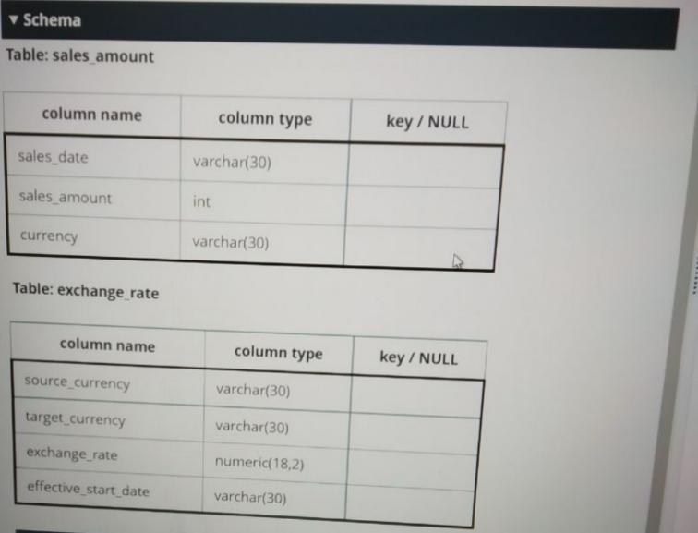

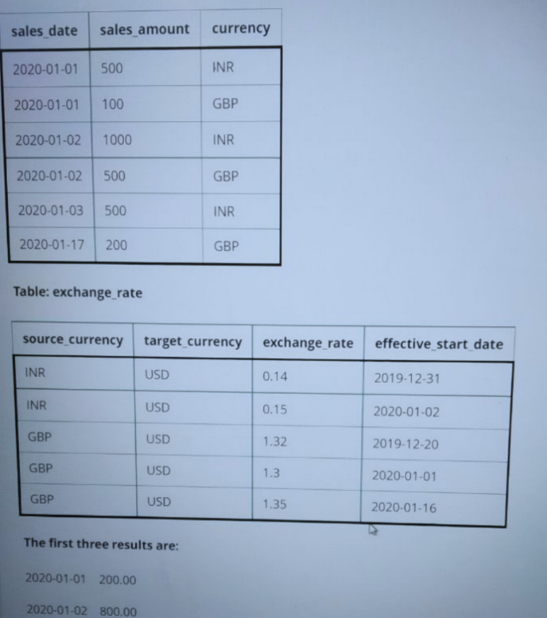

**Schema table has not been provided for the following question**

2) Write an SQL query to display:

The usemame of the customers who have placed an order.

Your output should contain 1 column in the below-mentioned order.

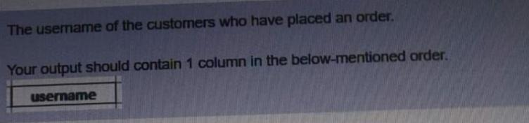

You can view the database schema by clicking the View Schema tab at the bo query window on the right-hand side of the screen.

**Schema table has not been provided for the following question**

3) Write an SQL query to display.

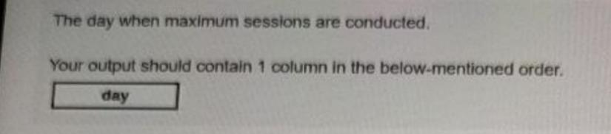

You can view the database schema by clicking the View Schema tab at the bo query window on the right-hand side of the screen.

**Schema table has not been provided for the following question**

4) Write an SQL query to display:

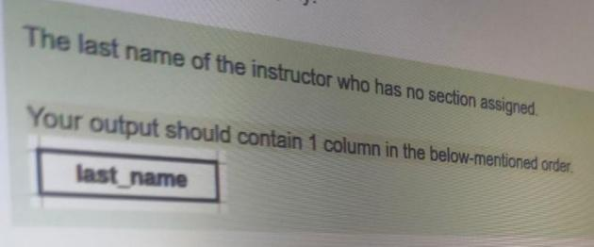

You can view the database schema by clicking the View Schema tab at the bo query window on the right-hand side of the screen.

**Schema table has not been provided for the following question**

5) Write an SQL query to display:

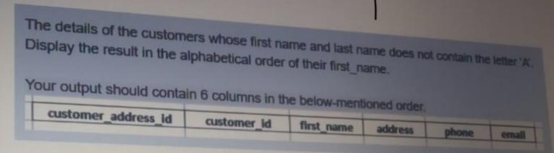

You can view the database schema by clicking the View Schema tab at the bo query window on the right-hand side of the screen.

1.

Write an SQL query to display:

The details of the customers whose first name and last name does not contain the letter 'A'. Display the result in the alphabetical order of their first_name.

|  |  |  |  |  |  |
| --- | --- | --- | --- | --- | --- |
| Customer_ address_id | Customer_id | first_name | address | phone | email |

Your output should contain 6 columns in the below-mentioned order.

You can view the database schema by clicking the View Schema tab at the bottom of the query window on the right-hand side of the screen.

2.

Write an SQL query to find:

The type description and the count (use alias count) of each type of train from the train details table.

Your output should contain 2 columns in the below-mentioned order.

|  |  |
| --- | --- |
| type_description | count |

You can view the database schema by clicking the View Schema tab at the bottom of the query window on the right-hand side of the screen.

3.

Write an SQL query to find

The employee ID, employee name, department ID and department name of all employees who have been assigned a department

Your output should contain 4 columns in the below-mentioned order.

|  |  |  |  |
| --- | --- | --- | --- |
| EMPID | EMPNAME | DEPTID | DEPTNAME |

You can view the database schema by clicking the View Schema tab at the bottom of the query window on right-hand side of the screen.

4.

Write an SQL query to find

The employee ID and employee name of all the employees who have not been assigned a department yet

Your output should contain 2 columns in the below-mentioned order

|  |  |
| --- | --- |
| EMPID | EMPNAME |

You can view the database schema by clicking the View Schema tab at the bottom of the query window on the right-hand side of the screen

5.

Write an SQL query to display:

The employee ID, employee name, date of birth (DOB) and age (in years with decimals) of all employees (use alias name Age).

The result must be sorted in ascending order as per the employee ID.

Note: Floor your age variable.

Your output should contain 4 columns in the below-mentioned order

|  |  |  |  |
| --- | --- | --- | --- |
| EMPID | EMPNAME | DOB | AGE |

You can view the database schema by clicking the View Schema tab at the bottom of the query window on the right-hand side of the screen

6.

Write an SQL query to display:

The details of the customers whose first name and last name does not contain the letter 'A'.

Display the result in the alphabetical order of their first_name.

Your output should contain 6 columns in the below-mentioned order.

|  |  |  |  |  |  |
| --- | --- | --- | --- | --- | --- |
| Customer_address_id | Customer_Id | First_name | address | phone | email |

You can view the database schema by clicking the View Schema tab at the bottom of the query window on the right-hand side of the screen.

7.

Write an SQL query to display:

The department name for which no instructors are available.

Your output should contain 1 column in the below-mentioned order.

|  |
| --- |
| name |

You can view the database schema by clicking the View Schema tab at the bottom of the query window on the right-hand side of the screen.

8.

Write an SQL query to display:

The username of the customers who have placed an order

Your output should contain 1 column in the below-mentioned order.

|  |
| --- |
| username |

You can view the database schema by clicking the View Schema tab at the bottom of the query window on the right-hand side of the screen.

9.Four different electronic devices make a beep after every 30 minuties,1 hour, 1 hour 30 minutes and 1 hour 45 minutes respectively. All the devices beeped together at 12 noon. Then will again beep together at:

12 am

3 am

6 am

9 am

10.

Write an SQL query to display:

The details of the costliest product.

Your output should contain 4 columns in the below-mentioned order.

|  |  |  |  |
| --- | --- | --- | --- |
| product_id | code | name | unit price |

You can view the database schema by clicking the View Schema tab at the bottom of the query window on the right-hand side of the screen

11.

Write an SQL query to display:

The number of full time and part time instructors

Your output should contain 2 columns in the below-mentioned order

|  |  |
| --- | --- |
| type | count |

Use Alias count for the second column

You can view the database schema by clicking the View Schema tab at the bottom of the query window on the night-hand side of the screen

12.

Write an SQL query to display

The number of students who have opted for BSc Mathematics (use alias no_of_students)

Note: A student must be registered if he has opted for a course and a course is taught under a section. Also the course name and course type are stored as the "Course” table

Your output should contain 1 column in the below mentioned order

|  |
| --- |
| No_of_students |

You can view the database schema by clicking the View Schema tab at the bottom of the query window on the right-hand side of the screen.

13.

The last name of the students who registered in the month of June. Arrange the output data in the ascending order of their last name

Your output should contain 1 column in the below-mentioned order

|  |
| --- |
| last name |

You can view the database schema by clicking the View Schema lab at the bottom of the query window on the right-hand side of the screen